Banking Transaction Fraud Detection
Teaching Notes
Data Quality and Feature Engineering at Scale

Contents
Contents 2
1. Why This Data Looks Messy on Purpose 3
The Three Source Extracts 3
2. Understanding Missing Data: Four Mechanisms 3
MCAR — Missing Completely At Random 3
MAR — Missing At Random (explained by an observed column) 3
MNAR — Missing Not At Random 4
Merge-Induced Missingness (a fourth, practical category) 4
3. Matching Treatment to Mechanism 5
4. Outliers: When "Noise" Is Actually the Signal 5
5. Feature Engineering at Scale 6
Ratios 6
Velocity 6
Interaction Flags 6
Frequency Encoding 7
6. Why ~190 Columns Isn't ~190 Signals 7
7. No Leakage: Fit on Train, Apply Everywhere 7
8. Choosing the Right Metric for Rare Events 7
PR-AUC 8
Recall, Precision, and the Threshold Trade-off 8
9. Does Data-Prep Effort Even Matter? It Depends on the Model. 8
10. Practical Guidance 9
Summary Cheat Sheet 10
Missing-Data Mechanisms 10
Outlier Judgment 10
No-Leakage Checklist 10
Metrics for Rare Events 10
Data-Prep Effort 10

1. Why This Data Looks Messy on Purpose
Every fraud-detection system pulls data from more than one place: a KYC and credit-bureau system that knows who a customer is, a core banking system that knows their accounts and transaction history, and a transaction/device-log system that knows what is happening right now. None of these systems were built together, and none of them guarantee that every field is filled in for every customer. That is not a flaw in this case study's data, it is a faithful reproduction of what a real fraud analyst inherits on day one.
This case study works with three such extracts, merged into a single table of roughly 100,000 rows and 186 columns. Before any model can be trusted, that data has to be understood, cleaned, and engineered, without accidentally scrubbing away the very extreme values that make fraud detectable in the first place.

The Three Source Extracts
- customer_profile.csv — one row per customer: demographics, credit bureau fields, and optional KYC enrichment fields.
- account_summary.csv — one row per customer who has synced to core banking: account info and ~120 transaction-window aggregate columns.
- transaction_events.csv — one row per customer, always present: the transaction under review, device signals, and the fraud label.
A left-join of transaction_events with the other two extracts (on Customer_ID) produces the merged table used throughout this case study. 2,312 of 100,000 customers (2.31%) have no row in account_summary.csv at all, that gap itself turns out to be one of the four missing-data mechanisms covered next.

2. Understanding Missing Data: Four Mechanisms
"Missing" is not one thing. Statisticians distinguish three classic mechanisms, and this case study adds a fourth that shows up specifically when combining multiple data sources. Which mechanism applies changes what the correct treatment is, so diagnosing it comes first.

MCAR — Missing Completely At Random
The chance a value is missing has nothing to do with anything, not the value itself, not any other column. In this data, the optional KYC enrichment fields (secondary phone, LinkedIn verification, referral code, and similar) are missing 78%–91% of the time simply because they are optional at onboarding. Whether a given customer filled one in tells you nothing about their risk.

MAR — Missing At Random (explained by an observed column)
The chance a value is missing depends on another column you can see, not on the missing value itself. Two clean examples appear in this data:
- The 30-day and 90-day transaction aggregates are missing almost exactly when Account_Age_Days is younger than that window, they simply do not exist yet for a new account.
- The entire account_summary row is missing for customers who joined very recently (Customer_Since_Days under 30 days: 17.3% missing, versus 0.1% for customers with over a year of tenure), a sync-lag pattern between two internal systems.
Both are fully explainable using a column that is always observed, which is exactly what makes MAR tractable: a good imputation strategy can lean on that explaining column.

MNAR — Missing Not At Random
The chance a value is missing depends on the value itself, which is precisely what makes MNAR the hardest case: you cannot fully correct for it using only the columns you can see. In this data, Annual_Income is missing more often for lower earners and for harder-to-verify employment types (10.9% missing for Salaried employees versus 27.9% for Unemployed applicants). The employment-type pattern is visible and testable; the income-level dependence underneath it is not, you can reason about it from domain knowledge, but you cannot prove it from the data alone.

Merge-Induced Missingness (a fourth, practical category)
When a model's training table is assembled from multiple source systems, missingness can arise purely from the join, independent of any single source file's own quality. The 2.31% of customers absent from account_summary.csv is this case study's example, it behaves like MAR (explainable by Customer_Since_Days) but the mechanism is a pipeline integration gap, not a property of any one table.
Figure 1 — Missing-data percentage across the 158 (of 186) merged columns that have any missing values.
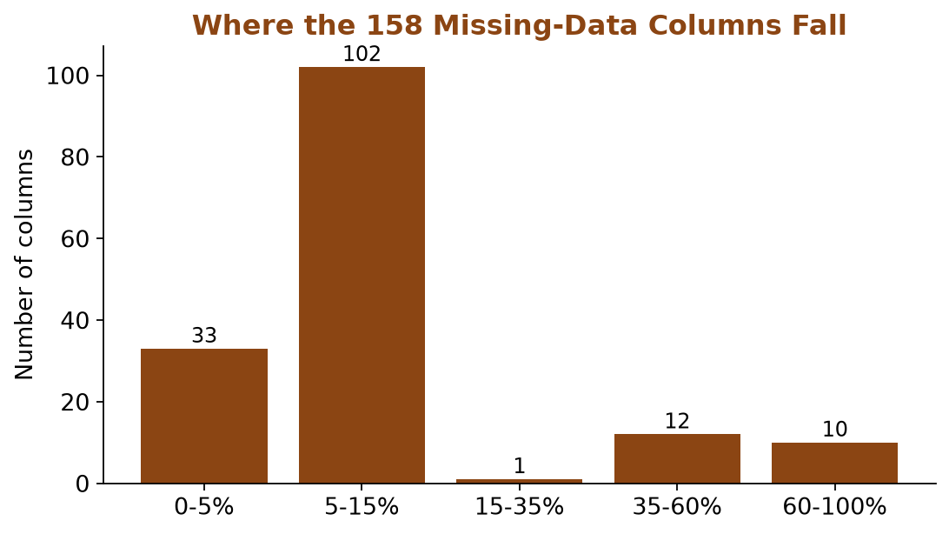

3. Matching Treatment to Mechanism
The temptation with a wide, messy table is to apply one rule everywhere (drop anything above X% missing, or impute everything with the mean). That is exactly the "naive" approach this case study tests, and deliberately does not recommend. Four mechanisms got four different, defensible treatments:
Situation | Treatment | Why
Near-unique identifier fields (phone number, referral code) | Drop outright | Not usable as a model feature even when present
High-missingness field that may carry signal (bureau block, income) | Add a _was_missing indicator, then impute | Missingness itself may predict risk
High-missingness categorical field | Fill with an explicit "Missing" category | Missing is a legitimate state, not noise
Low/medium-missingness numeric field (transaction aggregates) | Impute with the median | Skewed data, a mean gets pulled by outliers

For Annual_Income specifically, a single global median is the wrong number for every customer: a Student's typical income and a Salaried employee's typical income are not remotely the same. Imputing by group (median income within each Employment_Type, computed on the training split only) is more honest than one number for everyone.

4. Outliers: When "Noise" Is Actually the Signal
The standard instinct with outliers is to cap or remove them. For Transaction_Amount, that instinct is actively harmful here. In the training split, just 9.6% of transactions sit above the IQR high fence or below the 1st percentile, yet those rows contain 701 of 1,258 training-set fraud cases, 55.7% of all fraud. Two different fraud patterns live in those tails: very small "card testing" amounts and very large "cash-out" amounts.
55.7% of fraud sits in just 9.6% of the data (the transaction-amount tails)
Blindly capping or removing these values would delete most of the model's fraud signal along with the noise. The fix is to stop treating extremity as something to clean, and start treating it as a feature: an Is_Extreme_Amount flag, built from a fence fit on the training split only.
Figure 2 — Fraud rate is roughly 12x higher among transactions flagged as amount-extreme.
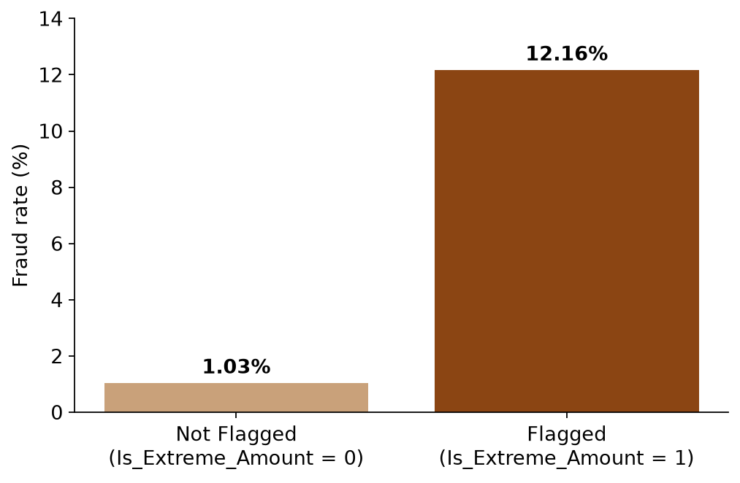
Not every extreme value tells the same story. Age and Annual_Income also contain values that are simply impossible (negative age, age over 100, non-positive income), a small number of rows (115 of 60,000 in the training split have age under 0 or over 100). These are ordinary data-entry errors, carry no fraud signal, and are safe to clip. The lesson is not "never touch outliers", it is that outlier treatment needs the same case-by-case judgment as missing data.

5. Feature Engineering at Scale
With ~190 raw columns, feature engineering here is less about inventing a single clever ratio and more about applying a small catalog of techniques systematically:

Ratios
Amount_to_Balance_Ratio and Amount_to_Limit_Ratio express the transaction relative to the customer's own financial position, not in isolation.

Velocity
Velocity_1h_vs_90d compares a customer's short-window transaction rate to their own long-run baseline, a spike relative to yourself, not to the population.

Interaction Flags
New_Device_and_Foreign and OddHour_and_ExtremeAmount encode conditions that only matter in combination, a new device alone is common; a new device plus a foreign transaction is not.

Frequency Encoding
Merchant_Category_Freq converts a categorical column into how common that category is, useful for high-cardinality fields where one-hot encoding would explode the column count.
Every one of these is fit (where it needs fitting, like the frequency map) on the training split only, and every raw ingredient it depends on (balances, transaction counts, the current transaction's own fields) was already cleaned in the previous two sections.

6. Why ~190 Columns Isn't ~190 Signals
Rolling-window feature stores, count/sum/average/max over several time windows (1 hour, 24 hours, 7/30/90 days) and several channels (ATM, POS, online, wire, international), generate columns fast. Many of them move together almost mechanically: a customer's 90-day transaction count is naturally correlated with their 30-day count for the same channel.
Measuring pairwise correlation among the 120 transaction-aggregate columns (on the training split only) and dropping one column from every pair above 0.95 correlation removed 17 columns with no loss of information, redundant, not independent, signal.

7. No Leakage: Fit on Train, Apply Everywhere
This is the single most important discipline in the whole case study, and the easiest one to get quietly wrong. Every statistic that gets baked into a feature, an imputed median, an outlier fence, a frequency-encoding map, a decision about which correlated column to drop, must be computed from the training split only, then applied unchanged to validation and test.
Fit on train. Apply to val and test. Never the other way around.
The risk is subtle: if a median or a fence is computed using the full dataset (including rows that will later be evaluated as "test"), information from those test rows has quietly leaked into a value the model gets to see during training. With a dataset this large the numeric effect is often tiny, but the discipline matters regardless, on a smaller dataset, or in a different problem, that same shortcut can meaningfully inflate reported performance. Getting the habit right here is what makes it safe elsewhere.
The same discipline applies to threshold selection later in the pipeline: the classification threshold is tuned by looking at performance on the validation set, then evaluated, once, on the test set. The test set is never used to make a decision, only to report a final number.

8. Choosing the Right Metric for Rare Events
At roughly 2.1% fraud prevalence, accuracy is close to meaningless (a model that predicts "never fraud" would be right 97.9% of the time). ROC-AUC is better but still has a blind spot: it is dominated by the huge number of easy true negatives, so it can look almost identical across two models that actually differ meaningfully in how well they rank fraud cases near the top of a list.

PR-AUC
Precision-Recall AUC only cares about ranking the rare positive class well against the false positives near the top of the ranking, exactly what a fraud investigator's queue looks like.

Recall, Precision, and the Threshold Trade-off
At the default 0.5 threshold, the Gradient Boosting model in this case study catches 91.9% of fraud but at only 29.4% precision, about 7 of every 10 flagged transactions are false alarms. Tuning the threshold on the validation set (to 0.94) trades recall down to 66.0% for precision up to 69.8%, improving F1 from 0.446 to 0.678. Neither threshold is "correct" in the abstract, the right choice depends on how many alerts the fraud team can actually investigate.
Threshold | Recall | Precision | F1
Default (0.5) | 91.9% | 29.4% | 0.446
Tuned (0.94) | 66.0% | 69.8% | 0.678

9. Does Data-Prep Effort Even Matter? It Depends on the Model.
Every technique in this case study, missingness indicators, group-aware imputation, outlier feature-ization, engineered ratios, correlation pruning, was compared honestly against a "naive" baseline (blind mean imputation, no engineering, no pruning), using the exact same training data and the exact same train/validation/test split, on two different model families.
Figure 3 — The same data-prep work, tested on two model families.
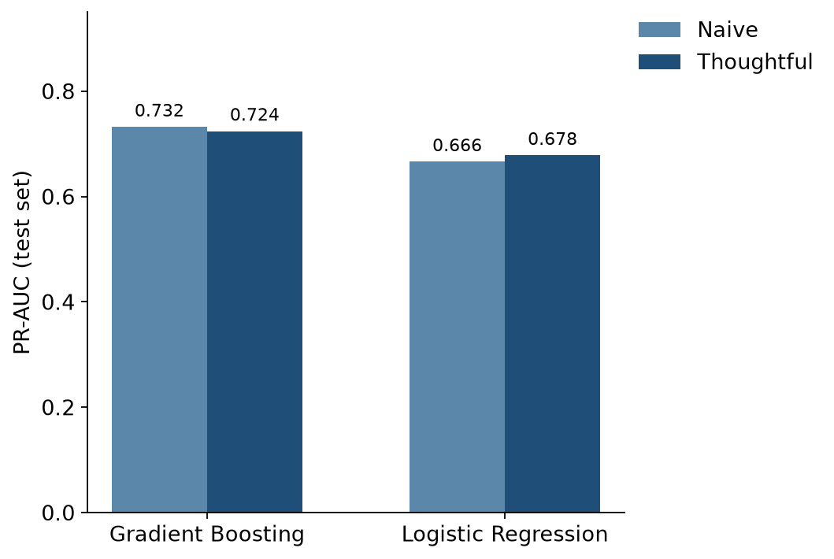
For Gradient Boosting, the two pipelines score almost identically (PR-AUC 0.732 naive vs. 0.724 thoughtful, naive even edges ahead slightly). That is a real result worth reporting honestly, not a failure to hide. Tree ensembles split on raw thresholds, so they are largely insensitive to how a value was imputed, whether an outlier was capped, or whether a ratio was pre-computed rather than left for the model to approximate through splits.
For Logistic Regression, the same thoughtful pipeline gives a real, consistent lift (PR-AUC 0.678 vs. 0.666, and every other metric moves the same direction). Linear models cannot construct a ratio or an interaction on their own, and are sensitive to how imputation shifts a distribution, exactly the properties the earlier Feature Engineering case study relied on.
The practical takeaway: match data-prep investment to the model family actually being deployed. For a tree ensemble, this work is still worth doing for documentation, auditability, and robustness against future drift, just don't sell it on a metric lift it doesn't deliver. For an interpretable linear scorecard (common in regulated banking specifically because it is explainable), the same work measurably improves the model.

10. Practical Guidance
- Diagnose the missing-data mechanism (MCAR / MAR / MNAR / merge-induced) before choosing a treatment, one blanket rule is rarely right for a whole table.
- Never impute or cap using statistics computed on data the model will later be evaluated against, fit every preprocessing decision on the training split only.
- Before capping an outlier, check what it correlates with, sometimes the extreme values are exactly what you are trying to detect.
- A wide feature store has redundancy built in by construction, prune correlated columns rather than assuming more columns means more signal.
- Report PR-AUC and recall-at-a-chosen-precision alongside (not instead of) ROC-AUC whenever the event you care about is rare.
- Test whether data-prep effort actually moves your model's metric, for the model family you are actually deploying, before assuming it always helps.

Summary Cheat Sheet

Missing-Data Mechanisms
- MCAR: missing for no reason related to anything observed or unobserved (optional fields).
- MAR: missing rate explained by another observed column (young accounts, new customers).
- MNAR: missing rate depends on the value itself, not provable from the data alone (income).
- Merge-induced: missing because a source system's row doesn't exist yet, a pipeline signal.

Outlier Judgment
- Data-entry errors (impossible ages, negative income): safe to clip.
- Domain-meaningful extremes (transaction amount tails): feature-ize, don't scrub.

No-Leakage Checklist
- Impute, encode, and prune using training-split statistics only.
- Tune thresholds on validation; report final numbers on test, exactly once.

Metrics for Rare Events
- Accuracy: misleading. ROC-AUC: dominated by easy negatives. PR-AUC: the honest one.
- Pick the operating threshold based on investigation capacity, not the 0.5 default.

Data-Prep Effort
- Tree ensembles: largely insensitive to imputation/outlier/scale choices.
- Linear models: measurably improved by the same careful preparation.

